Ideation Phase

Define the Problem Statements

Date | 28 OCT 2025
Team ID | NM2025TMID05124
Project Name | Laptop Request Catalog Item

Customer Problem Statement Template – Laptop Request Catalog Item
Customers face challenges when requesting laptops due to unclear processes, limited visibility, and inconsistent approval workflows. This often leads to delays in laptop allocation, miscommunication between departments, and difficulty tracking request status. As a result, employees experience downtime, and IT teams struggle to manage inventory efficiently.
They need a streamlined system that ensures every laptop request is properly logged, reviewed, and approved before fulfillment. The process should prevent duplicate or unauthorized requests, maintaining data accuracy and accountability across departments.
A clear notification system or automated approval workflow would help users stay informed about request progress and reduce manual follow-ups. This solution will enhance operational efficiency, improve transparency, and boost user confidence in the laptop request catalog system.
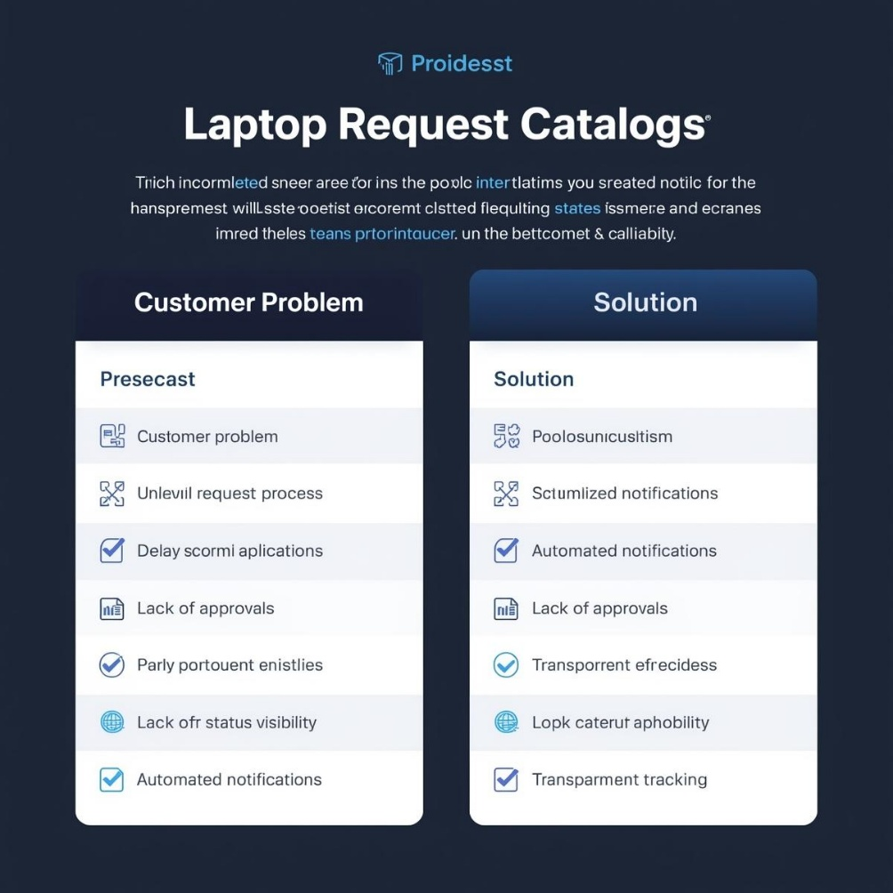

Example:

Problem Statement (PS) | I am (Customer) | I’m trying to | But | Because | Which makes me feel
PS-1 | An Employee | Request a laptop for work | the process is manual and slow | there’s no self-service catalog item to submit requests easily | frustrated and delayed in getting my laptop
PS-2 | An Admin | Track and approve laptop requests | there’s no automated workflow | approvals have to be done manually through emails | overloaded and inefficient
PS-3 | An IT Support Staff | Assign laptops to users quickly | request details are incomplete or unclear | the form doesn’t have dynamic fields to guide users | confused and prone to errors
PS-4 | An Employee | Reset my laptop request form | I entered wrong details by mistake | there’s no reset or clear option in the catalog form | stuck and annoyed
PS-5 | A Manager | Monitor laptop distribution | data is scattered across emails and sheets | there’s no centralized catalog report | worried about tracking and accountability

⬛✓⬛ Problem Statement PS 1:
As an employee, I am trying to request a laptop for my work, but the current process is completely manual and time-consuming. The absence of an automated service catalog item makes it difficult to submit accurate requests and track their approval status.

This limitation makes me feel frustrated and uncertain, as I have to rely on emails and follow-ups to know whether my request is approved or processed. It causes unnecessary delays in laptop provisioning and impacts my ability to start work efficiently.

I need a simplified and interactive laptop request catalog item that allows me to submit requests easily, ensures accurate data collection through dynamic fields, and provides real-time status updates to enhance transparency and efficiency

⬛✓ Problem Statement PS 2:
As an IT admin, I want to ensure that laptop requests are properly tracked and approved before devices are issued. However, the current process lacks automation and fails to provide alerts or summaries for pending approvals.
This causes delays in laptop provisioning and leads to confusion about request ownership and approval status. As a result, employees may experience extended waiting times and incomplete request handling, which impacts overall productivity and satisfaction.

